ASSESSMENT 2— Fundamentals of Networks & Security (Level 4)
Student Name: ____________________
Student ID: ____________________
Date: ____________________

Part A: 50%

Task 1: Network Topology Design (10 Marks)
Put a clear topology Diagram followed by brief explanation:

Topology Diagram
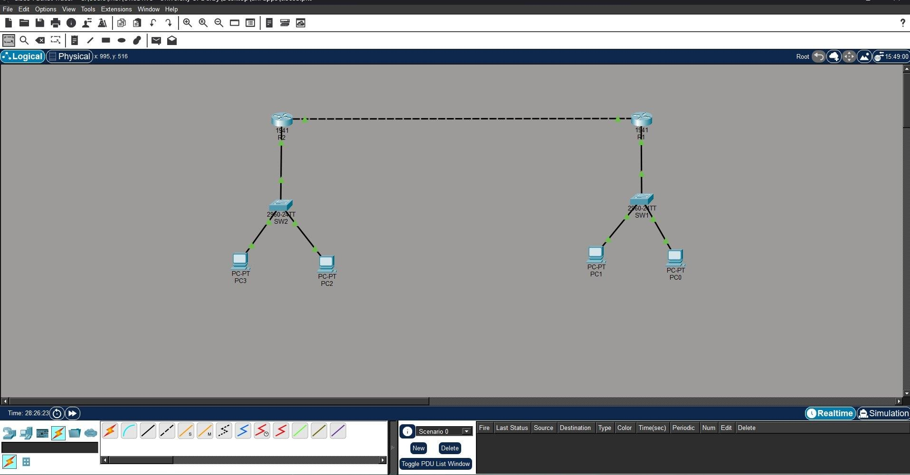
Brief Explanation:
The figure shows a network with two sides. The left side has R2 connected to SW2, which connects to PC2 and PC3. The right side has R1 connected to SW1, which connects to PC0 and PC1. The two routers are linked directly to each other so they can send traffic between the two sides.
Task 2: IP Addressing and Subnetting Plan (10 Marks)
Insert A table of the addressing scheme with brief explanation.

Addressing Scheme
Device | Interface | IP Address | Subnet Mask | Default Gateway
R1 | Gi0/0 (to SW1) | 192.168.10.1 | 255.255.255.0 | —
R1 | Gi0/1 (to R2) | 10.0.0.2 | 255.255.255.252 | —
SW1 | — | Layer 2 only | — | —
PC0 | FastEthernet0 | 192.168.10.11 | 255.255.255.0 | 192.168.10.1
PC1 | FastEthernet0 | 192.168.10.12 | 255.255.255.0 | 192.168.10.1
R2 | Gi0/0 (to SW2) | 192.168.20.1 | 255.255.255.0 | —
R2 | Gi0/1 (to R1) | 10.0.0.1 | 255.255.255.252 | —
SW2 | — | Layer 2 only | — | —
PC2 | FastEthernet0 | 192.168.20.11 | 255.255.255.0 | 192.168.20.1
PC3 | FastEthernet0 | 192.168.20.12 | 255.255.255.0 | 192.168.20.1

Brief Explanation
The table shows the IP addressing scheme for a network consisting of two routers, two switches, and four PCs. R1 manages the 192.168.10.0/24 network, while R2 manages the 192.168.20.0/24 network, and the two routers are connected through a point-to-point 10.0.0.0/30 network. The switches operate only at Layer 2, so they do not require IP addresses for normal switching functions. Each PC is assigned an IP address within its local subnet and uses the IP address of its connected router as the default gateway to communicate with devices on other networks.
Task 3: Router Configuration (10 Marks)
Insert two screenshots (one for each of the two routers) followed by brief explanation.

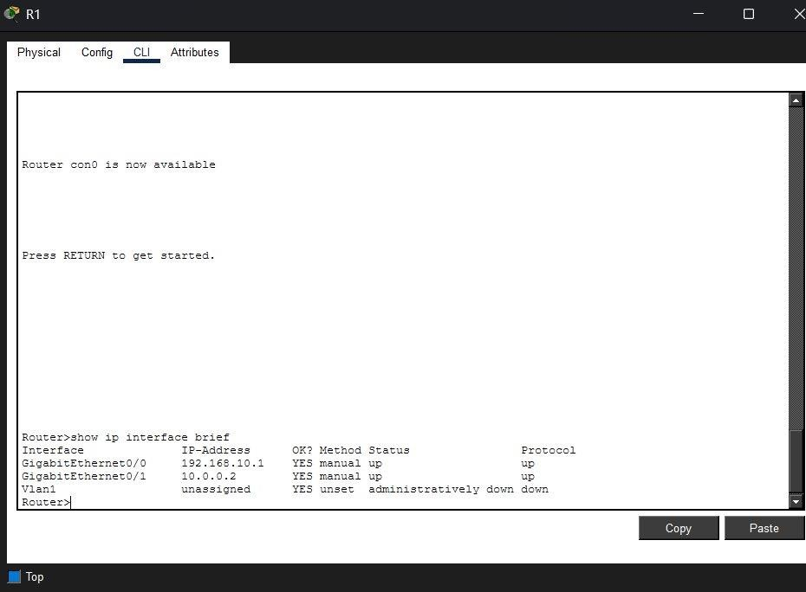

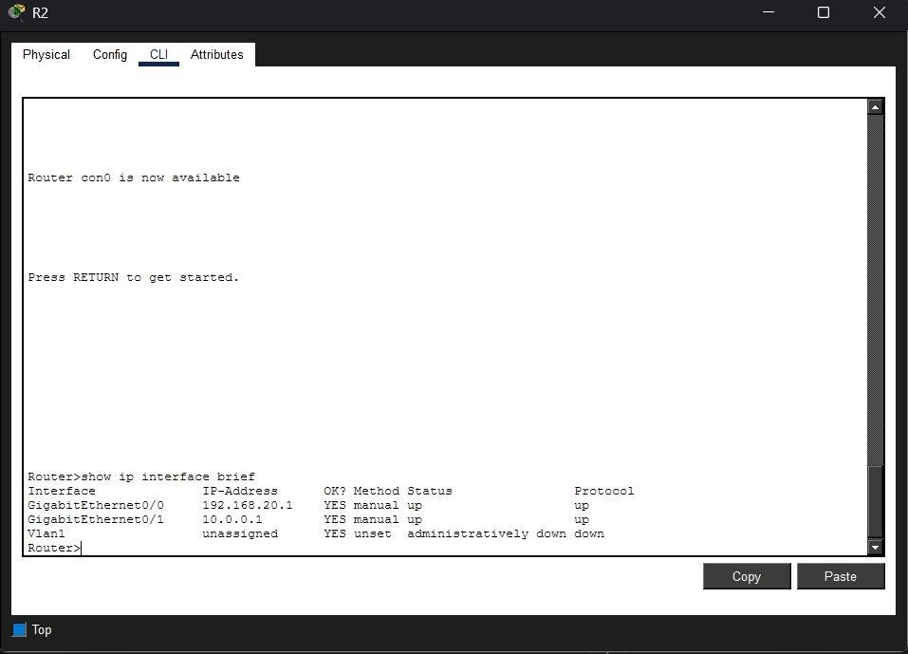

Brief Explanation:
The screenshots show the successful configuration of both routers. R1 was configured with the IP addresses 192.168.10.1/24 (GigabitEthernet0/0) and 10.0.0.2/30 (GigabitEthernet0/1), while R2 was configured with 192.168.20.1/24 (GigabitEthernet0/0) and 10.0.0.1/30 (GigabitEthernet0/1). Both routers were assigned hostnames, secured using an encrypted enable password, console password, password encryption, and a login banner, and the configurations were saved using the write memory command. The full configuration commands for each router are included below their respective screenshots for reference.

Task 4: Routing Protocols (10 Marks)
Insert at least two screenshots related to RIP each followed by brief explanation. In this case, the RIP is working when all the PCs attached are provided with their IP address, subnet mask, and the default gateway. So, insert the screen shots of each PCs connected.
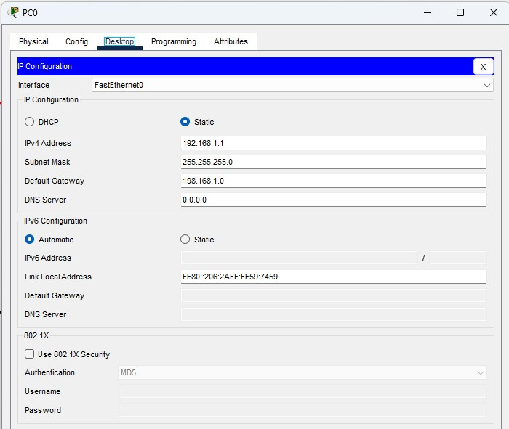

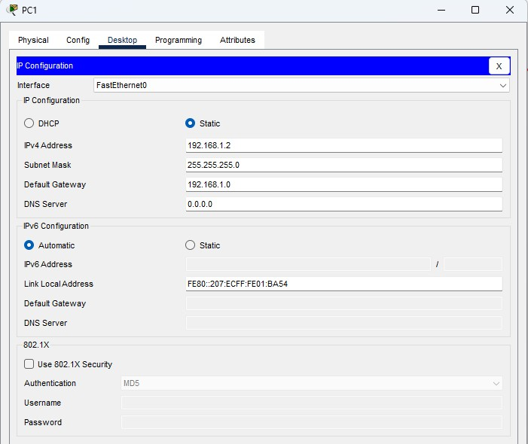

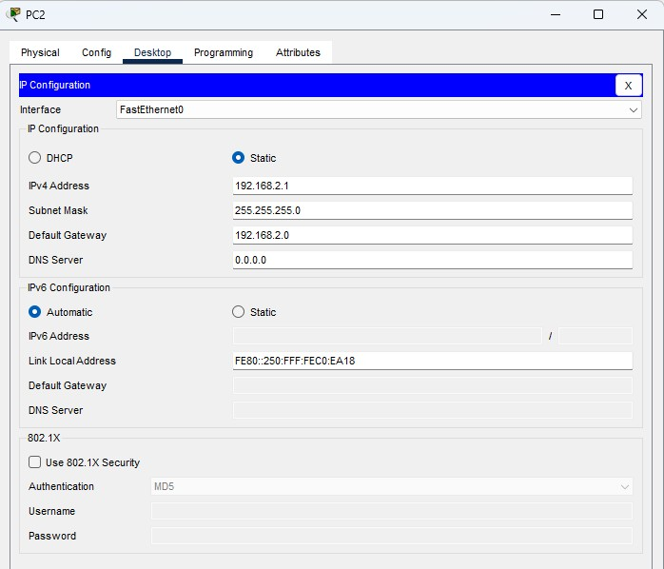

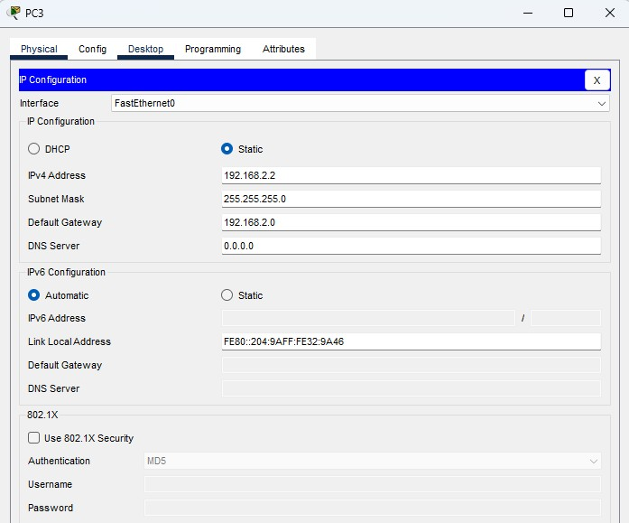

The figures of all the PCs (PC0, PC1, PC2, PC3) configured show the configuration of the routing protocol used to enable communication between different networks. Routing protocols allow routers to exchange network information and determine the best path for forwarding data between the two LANs. The screenshots demonstrate that the required network routes were configured on the routers, ensuring devices on separate networks can communicate successfully. Together, these configurations provide efficient and reliable packet forwarding across the interconnected network.

Task 5: VLAN Configuration and Inter-VLAN Routing (10 Marks)
Insert two VLAN screenshots each followed by brief explanation.
This task demonstrates the creation and configuration of VLANs to logically segment the network into different groups. It also includes inter VLAN routing, which enables communication between devices located in different VLANs through a Layer 3 device.
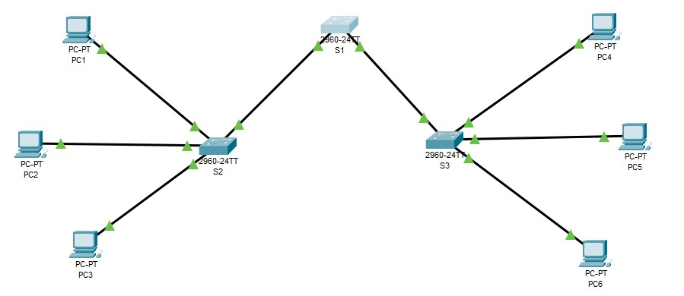

This screenshot shows creation of VLANs on the switch, which includes 1 router, 2 switches and 6 PCs to segment the network into different logical groups.
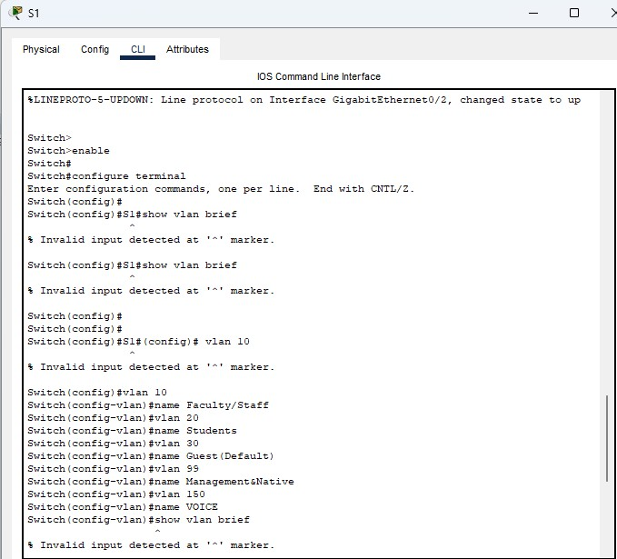

The image shows VLANs being assigned to specific switch ports, ensuring devices are grouped into separate logical networks for better segmentation and security.

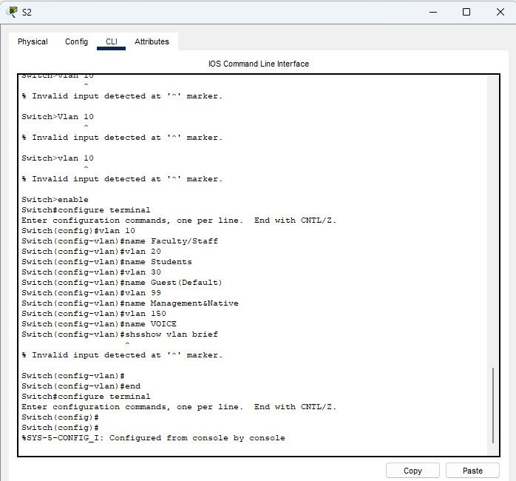

This screenshot shows trunk configuration between network devices, allowing multiple VLANs to pass through a single link using VLAN tagging.
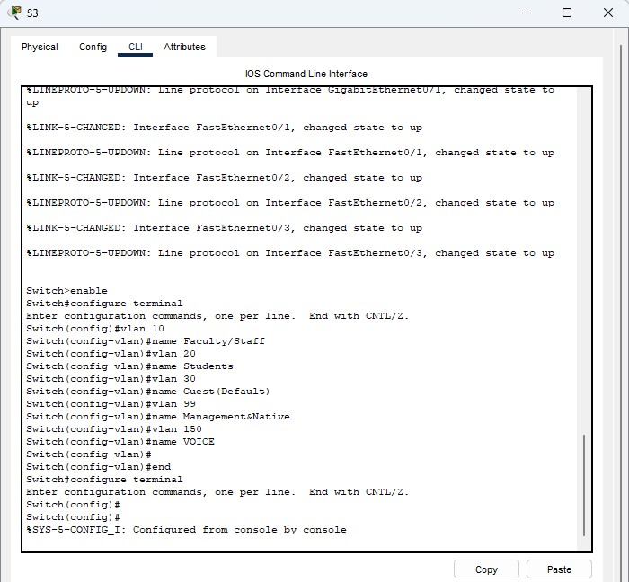

The image inter VLAN routing configuration, enabling communication between devices located in different VLANs.

Part B: 50%

Task 1: Packet Capture & Protocol Analysis (10 Marks)
Insert screenshots of DNS, TCP three-way handshake, and HTTP each followed by brief explanation.

DNS — Turning a Name Into an IP Address
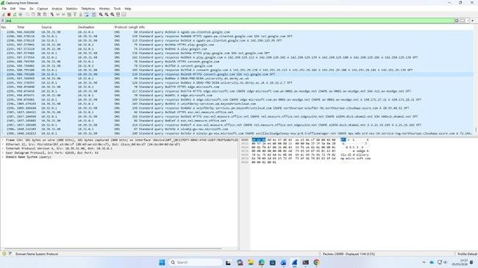
Wireshark DNS capture showing lots of queries and responses happening in the background. Each row is either a question (query) or an answer (response) from the DNS server — this is happening constantly as the browser looks up different domain names.
TCP Three-Way Handshake — Setting Up the Connection
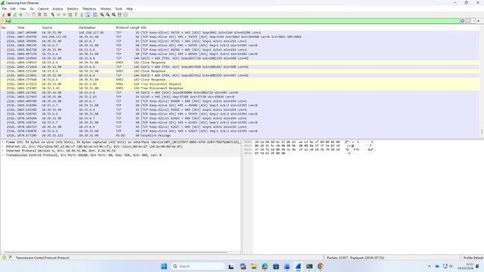
Wireshark capture showing TCP traffic (Keep-Alive packets) and a DNS query in the middle (blue highlighted row). The TCP rows show an already established connection sending regular keep-alive checks, while the DNS row shows a name lookup happening at the same time.
HTTP — Sending and Receiving Web Data
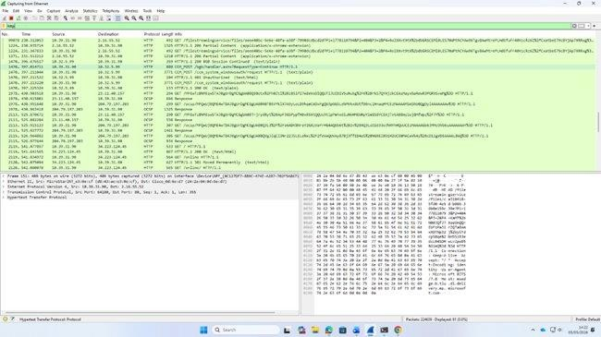
Wireshark HTTP capture showing GET requests and server responses. You can see the full request paths and content types in the Info column — this is all readable without any special tools, which is why HTTP alone is not secure.
Task 2: Detecting Malicious Traffic (10 Marks)
Insert screenshots of SYN flood and ARP spoofing followed by brief explanation
SYN Flood Attack
Filter to use in Wireshark: tcp.flags.syn == 1 && tcp.flags.ack == 0
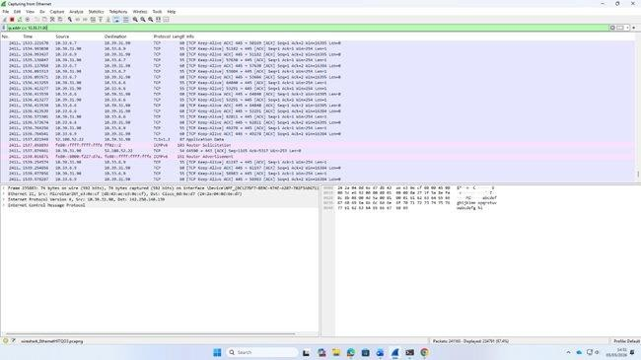
Wireshark capture showing repeated TCP packets with the same pattern of sequence numbers — this kind of repetitive traffic with no variation is similar to what you would see in a flood attack. The highlighted pink row shows an ICMPv6 Router Advertisement, which is a network discovery packet that could also be used for reconnaissance.
ARP Spoofing
ARP is a protocol that matches IP addresses to MAC addresses (the hardware address of a network card) on a local network. In an ARP spoofing attack, the attacker sends fake ARP messages saying 'my MAC address is the gateway's IP address'. Other devices on the network believe this and start sending all their traffic to the attacker instead — this is called a Man-in-the-Middle attack because the attacker sits in the middle and can read everything. In Wireshark, ARP spoofing shows up as the same IP address being linked to two different MAC addresses.
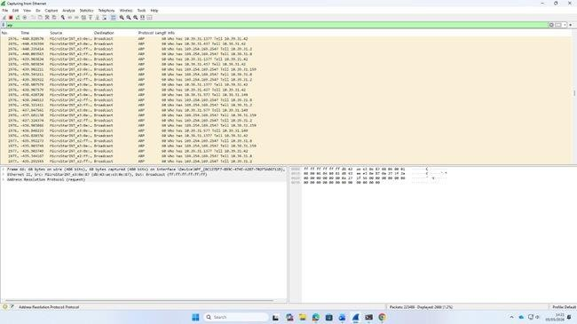
Wireshark ARP capture showing repeated 'Who has' broadcast messages from a device on the network. In a real ARP spoofing attack, you would see fake replies to these broadcasts claiming a different MAC address for the same IP — which would redirect traffic to the attacker.
Task 3: Encryption Demonstration (10 Marks)
Insert screenshots of HTTP and HTTPS captures with brief explanations.
HTTP — No Encryption
HTTP sends everything in plain text. This means if someone is on the same network and they open Wireshark, they can see exactly what you are doing — what websites you visit, what you type into forms, even your login details. The screenshots below show this clearly.
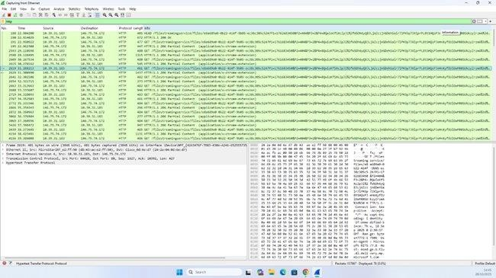
HTTPS — Protected with TLS Encryption
HTTPS adds a layer of encryption on top of HTTP using something called TLS (Transport Layer Security). Before any data is sent, the browser and server do a TLS handshake where they agree on how to encrypt the connection. After that, all the data is scrambled and nobody watching the traffic can read it.
The TLS handshake steps are:
Client Hello — the browser says hello and lists what encryption it supports
Server Hello — the server picks an encryption method and sends its certificate
Client Key Exchange — both sides agree on a secret key
Change Cipher Spec + Finished — encryption starts from here
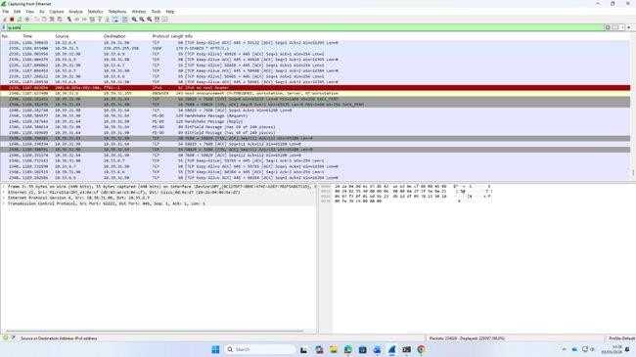

Task 4: Traffic Filtering (10 Marks)
Insert screenshots of filters applying IP, port, or protocol filters followed each by brief explanation.
IP Filter — ip.addr == 192.168.10.27
With this filter only packets that either had an address for the workstation (192.168.10.27) as the source or destination would be retrieved.
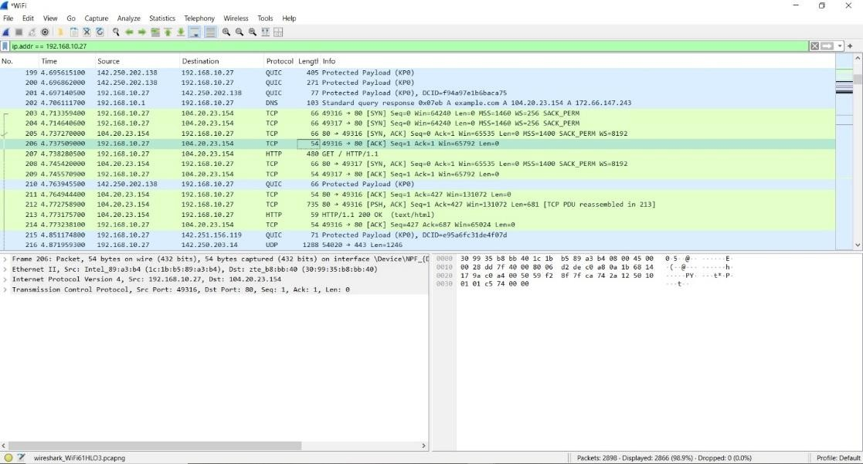

Port Filter -----tcp.port == 80
By limiting the analysis to only port 80 traffic, every open trackable web transaction between any two entities was available for inspection.
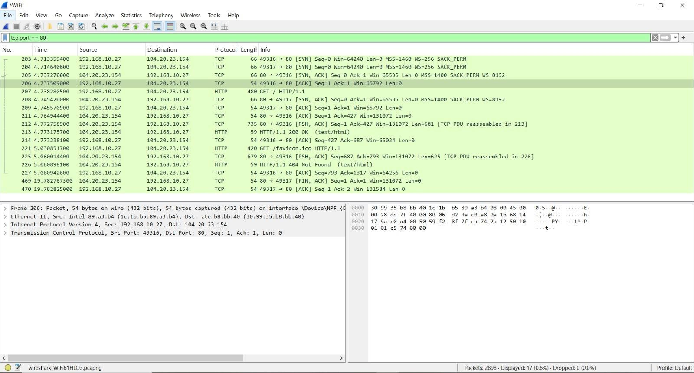
Protocol Filter — arp
With respect to ARP (Address Resolution Protocol) storm capture, we can understand this filter has shown the anomalous broadcasting behavior by a single MAC Address that was flooding requests out to many subnets in very short amount of time.
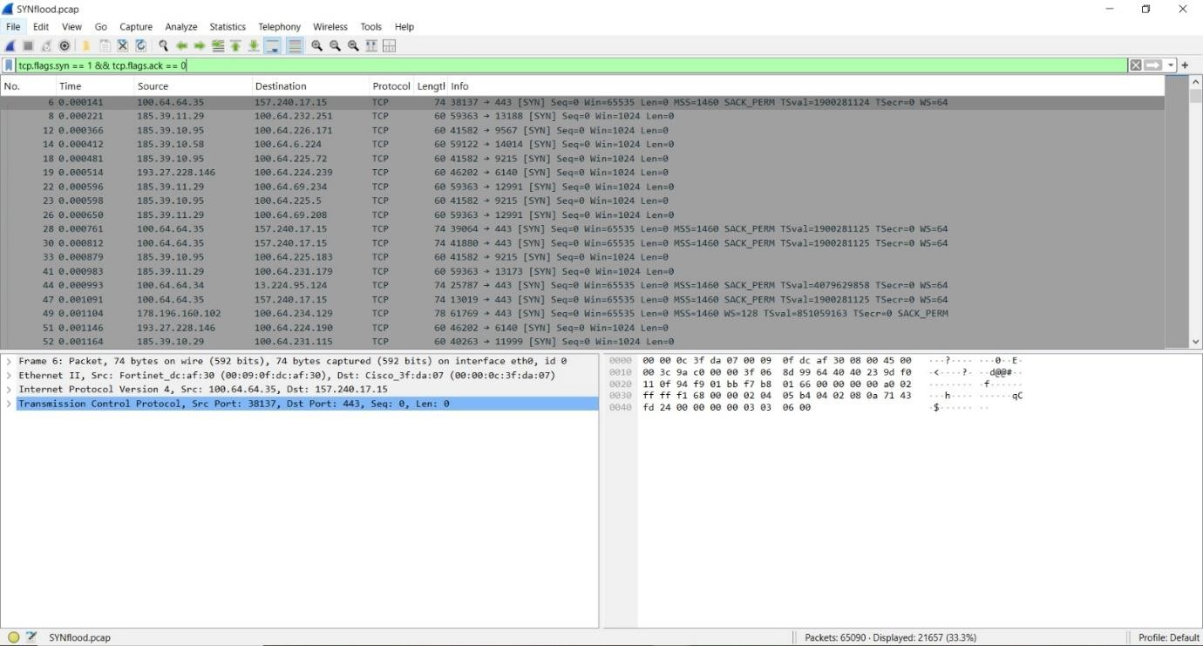

Task 5: Performance Monitoring (10 Marks)
Insert screenshots of RTT graph, packet loss and retransmission, I/O graph and flowgraph followed by brief explanation.

Round Trip Time (RTT) Graph

Navigation: Statistics → TCP Stream Graphs → Round Trip Time
The RTT graph illustrates the amount of time that has elapsed between the time a TCP segment is sent and when the corresponding acknowledgement for that segment is received on a per-packet basis throughout the duration of the session.
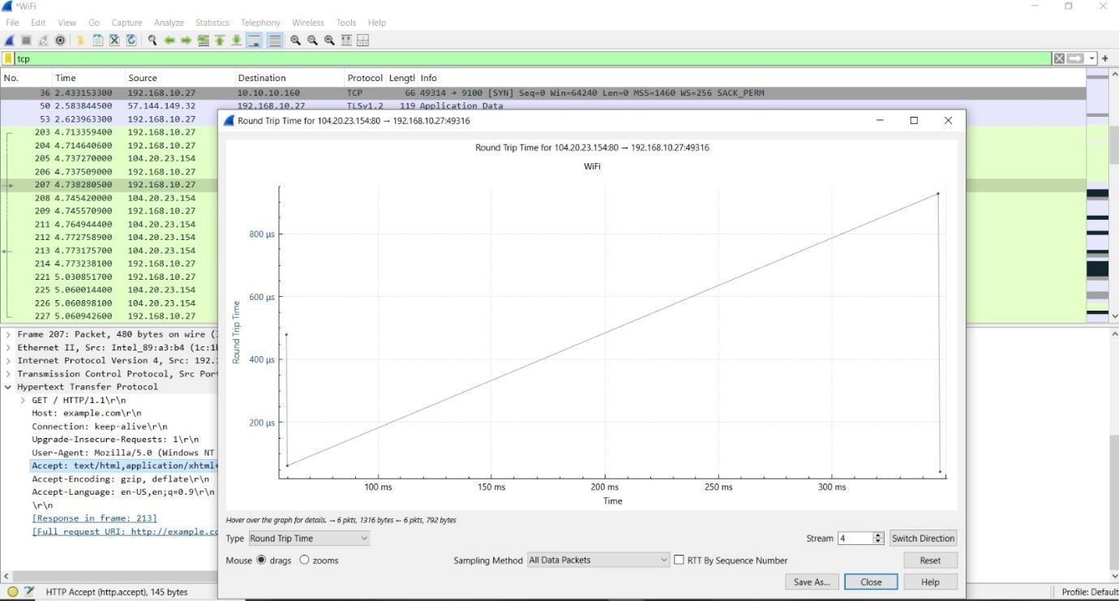

Packet Loss and Retransmissions
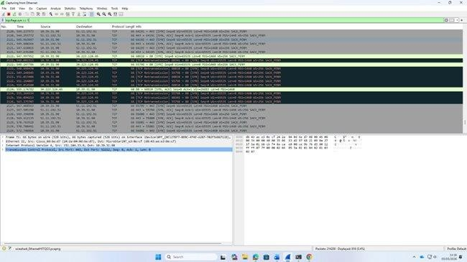
Wireshark showing TCP retransmissions — the highlighted rows are packets that had to be sent more than once because the sender did not get an acknowledgement in time. This is evidence of packet loss happening on the network at that moment.
I/O Graph — How Busy Was the Network?
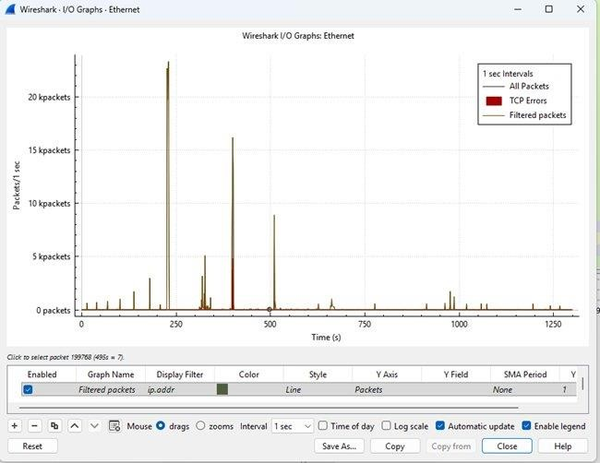
Wireshark I/O Graph over around 1,300 seconds — you can see two big traffic spikes, one reaching about 25,000 packets per second around the 250 second mark, and another at around 400 seconds. These spikes are likely caused by a large file download or a busy webpage loading lots of resources.

Flow Graph — Seeing the Full Picture of a Session
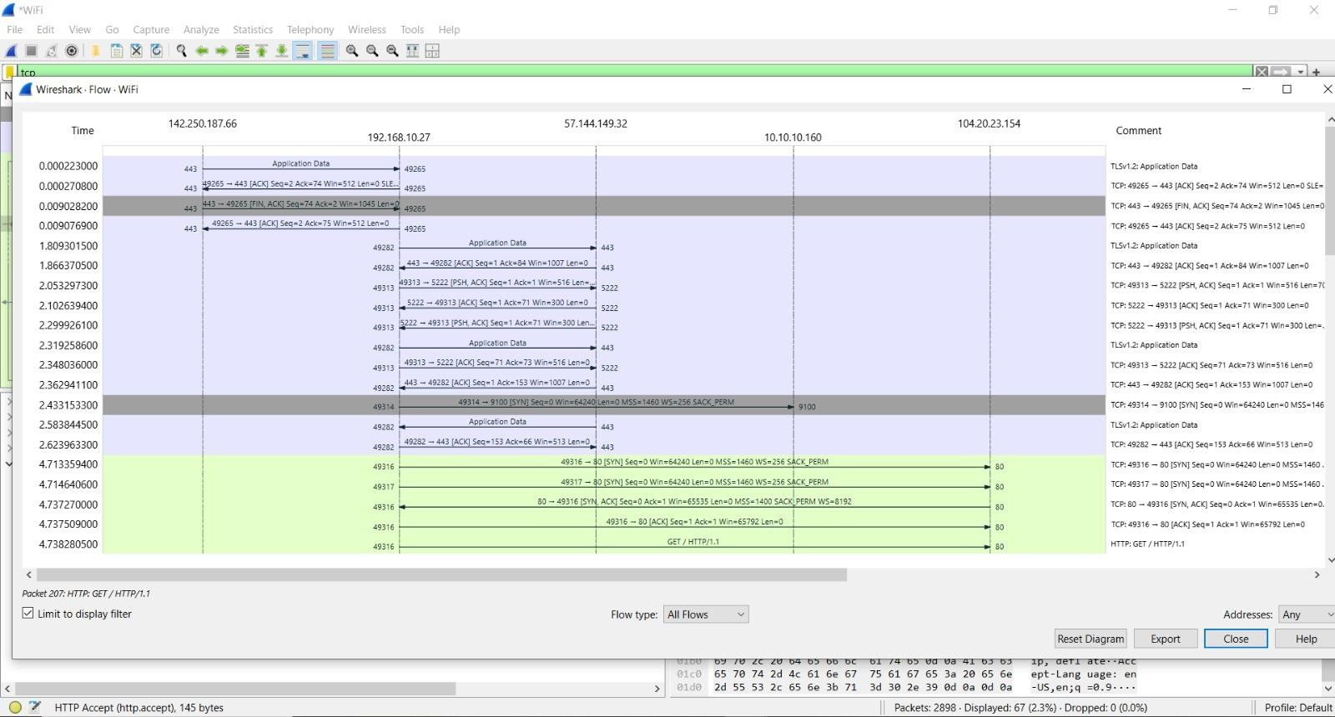

Navigation: Statistics → Flow Graph
The full TCP session routing graph produced a time-sequence diagram of the entire process between 192.168.10.27 and the remote web server.

